Technology in Healthcare
Student’s Name
Institutional Affiliation

Technology | Description of technology that improves patient experience (45 to 90 words) | Explanation of how technology improves patient experience (45 to 90 words) | Artifact that represents the technology* | APA Citation
1.Patient portals | Patient portal relates to a secure online website that gives patients 24-hour access to personal health information from anywhere with internet connectivity. Consequently, advanced portals enable patients to request prescription refills, schedule non –urgent appointments and secure exchange messages with the provider. Therefore, this benefits both the patient and the provider (Graetz et al., 2016). | Patient portals improve patient experience by making patients and their doctors to communicate effectively. Again, it is the best way for patients to access test results and other health information. For instance, a patient may have a question about the medication provided by the doctor; they can access the patient portal and send a message. Also, another alternative is that they can see test results for a test they have taken instead of physically going to see the physician for a follow up to get the results. They can see on the patient portal. | http://amitahealth.adam.com/content.aspx?productId=117&pid=60&gid=000880 | Graetz, I., Gordon, N., Fung, V., Hamity, C., & Reed, M. E. (2016). The digital divide and patient portals. Medical care, 54(8), 772-779.
2.communication methods | Many different communication methods within healthcare make the patient receives proper care. They include verbal and non-verbal communication (Otuzoğlu & Karahan, 2014).  Non-verbal communication ma entails facial expressions whereas verbal communication may include written communication. | Communication methods should always be perfected to enable the patient to understand all the instructions that the doctor gives him or her. On the contrary, without proper understanding, the patient will end up suffering. | 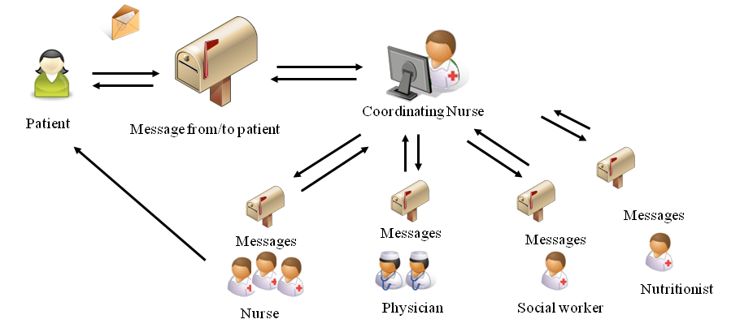  Communication in health care | Otuzoğlu, M., & Karahan, A. (2014). Determining the effectiveness of illustrated communication material for communication with intubated patients at an intensive care unit. International journal of nursing practice, 20(5), 490-498.
3.Telemedicine | Telemedicine is a two-way device that is used to ensure proper communication between the patient and the physician. | Telemedicine is an interactive communication device that allows the patient to experience consultation with a doctor much efficiently and faster. | 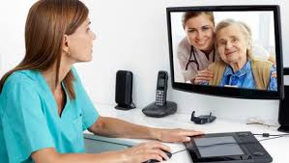 | Ayatollahi, H., Sarabi, F. Z. P., & Langarizadeh, M. (2015). Clinicians’ knowledge and perception of telemedicine technology. Perspectives in health information management, 12(Fall).
4. Patient care | Proper patient care technology relates to a way of improving medical safety, reducing potential medical errors and increasing access to medical information. It also deals with encouraging patient-centered care. Proper medical care can reduce medical error where electronic prescribing will allow clinicians to send prescriptions electronically to the pharmacy. | Patient care improves patient experience by reducing medical errors that may occur thus decreasing complications. Another issue is that increased patient-centered care leads to increased compliance and patient satisfaction. The physician may be able to access information of the patient on the online medical records. This may improve self-monitoring and patient convenience. | 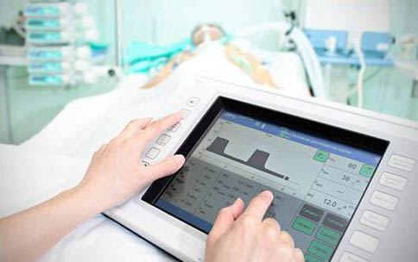 | Lavin, M. A., Harper, E., & Barr, N. (2015). Health information technology, patient safety, and professional nursing care documentation in acute care settings. Online J Issues Nurs, 20(6).
5. Online medical care | Online medical care relates to the modern way for the patient to communicate with their physician using the technology. Consequently, it is primarily used for advice and treatment of non-urgent medical conditions that do not require a physical exam. The patient and the physician communicates more efficiently concern patient concerns | Online medical care improves patient experience by making it easy for patients and physician to communicate easily concerning the patient concerns. It helps to in obtaining medical care for problems that do not require a physical examination (Shekelle, et al., 2014). | https://www.ncbi.nlm.nih.gov/pubmed/25474083 | Jones, S. S., Rudin, R. S., Perry, T., & Shekelle, P. G. (2014). Health information technology: an advanced and updated systematic review with a focus on meaningful use. Analysis of internal medicine, 160(1), 48-54.

